Screenshots or program listings must be copied into appropriate cells in the following table.
Save this evidence document as evidence_ followed by your centre number_ candidate number. For example: evidence_ zz999_9999 and insert your name, centre number and candidate number into the header above.
Examiners must be able to read the contents including any screenshots without the use of a magnifying glass. Answers that are not readable or missing will not be awarded any marks.
Save this evidence document at regular intervals, for example, every 10 minutes.
Question 1
Part 1(a)
{Copy and paste the program code for question 1(a) here}

Part 1(b)(i)
{Copy and paste the program code for question 1(b)(i) here}

Part 1(b)(ii)
{Copy and paste the screenshot for question 1(b)(ii) here}

Part 1(c)
{Copy and paste the program code for question 1(c) here}

Part 1(d)(i)
{Copy and paste the program code for question 1(d)(i) here}

Part 1(d)(ii)
{Copy and paste the screenshot(s) for question 1(d)(ii) here}

Question 2
Part 2(a)
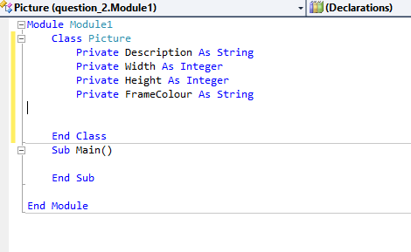

Part 2(b)
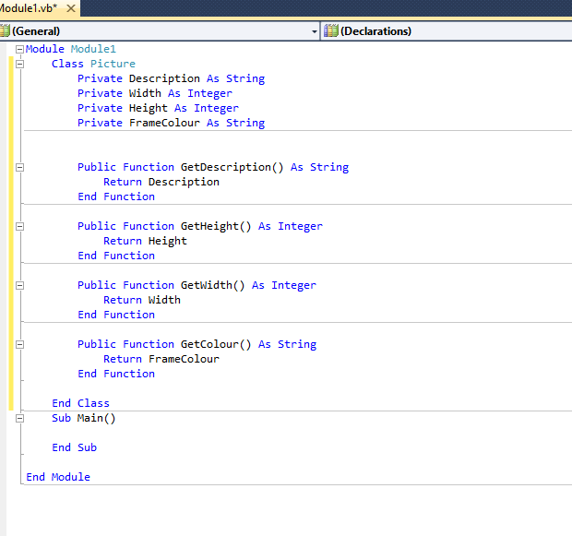

Part 2(c)
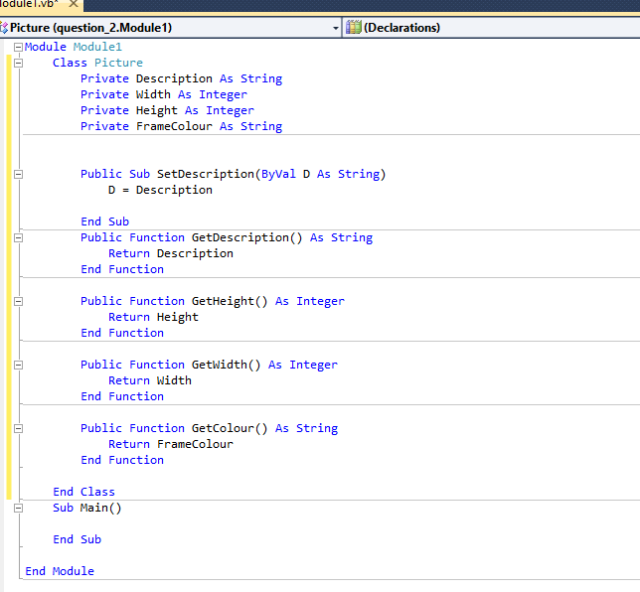

Part 2(d)
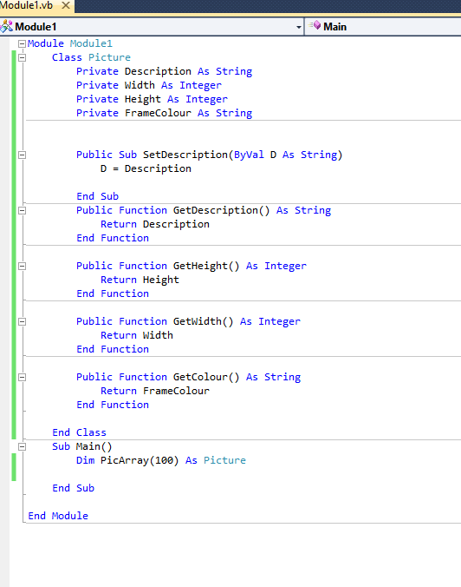

Part 2(e)
Module Module1

Class Pictures

Private Description As String
Private Width As Integer
Private Height As Integer
Private FrameColour As String

Public Sub New(ByVal D As String, ByVal W As Integer, ByVal H As Integer, ByVal F As String)
Description = D
Width = W
Height = H
FrameColour = F
End Sub

Public Sub SetDescription(ByVal D As String)
Description = D

End Sub
Public Function GetDescription() As String
Return Description
End Function

Public Function GetHeight() As Integer
Return Height
End Function

Public Function GetWidth() As Integer
Return Width
End Function

Public Function GetColour() As String
Return FrameColour
End Function

End Class
Function ReadData() As Pictures
Dim PicArray(100) As Pictures
Dim lineoftext As String
Dim filehandle As IO.StreamReader
Dim count As Integer
Dim D, W, H, F As String
filehandle = New IO.StreamReader("Pictures.txt")
count = 0

Do

D = filehandle.ReadLine()
W = filehandle.ReadLine()
H = filehandle.ReadLine()
F = filehandle.ReadLine()
count = count + 1
PicArray(count) = New Pictures(D, W, H, F)

Loop Until filehandle.EndOfStream
End Function
Sub Main()

End Sub

End Module

Part 2(f)
{Copy and paste the program code for question 2(f) here}

Part 2(g)
{Copy and paste the program code for question 2(g) here}

Part 2(h)
{Copy and paste the screenshot(s) for question 2(h) here}

Question 3
Part 3(a)
{Copy and paste the program code for question 3(a) here}

Part 3(b)
{Copy and paste the program code for question 3(b) here}

Part 3(c)
{Copy and paste the program code for question 3(c) here}

Part 3(d)(i)
{Copy and paste the program code for question 3(d)(i) here}

Part 3(d)(ii)
{Copy and paste the screenshot for question 3(d)(ii) here}

Part 3(e)(i)
{Copy and paste the program code for question 3(e)(i) here}

Part 3(e)(ii)
{Copy and paste the screenshot for question 3(e)(ii) here}

